NAMA : LINA NURULLAILI
NIM : K3521039
KELAS : A
LAPORAN UTS PEMWEB

- Menu Login
Script:
<?php
session_start();
require('koneksi.php');

$error = '';
$validate = '';

if( isset($_SESSION['username']) ) header('Location: index.php');

if( isset($_POST['login']) ){

$username = stripslashes($_POST['username']);
$username = mysqli_real_escape_string($koneksi, $username);
$password = stripslashes($_POST['password']);
$password = mysqli_real_escape_string($koneksi, $password);

if(!empty(trim($username)) && !empty(trim($password))){

$query = "SELECT * FROM user WHERE username = '$username'";
$result = mysqli_query($koneksi, $query);
$rows = mysqli_num_rows($result);

if ($rows != 0) {
$hash = mysqli_fetch_assoc($result)['password'];
if(password_verify($password, $hash)){
$_SESSION['username'] = $username;

header('Location: index.php');
}

} else {
$error = 'Register User Gagal !!';
}

}else {
$error = 'Data tidak boleh kosong !!';
}
}

?>

<!DOCTYPE html>
<html lang="en">
<head>

<meta charset="utf-8">
<meta name="viewport" content="width=device-width, initial-scale=1, shrink-to-fit=no">
<link href="https://cdn.jsdelivr.net/npm/bootstrap@5.0.2/dist/css/bootstrap.min.css" rel="stylesheet" integrity="sha384-EVSTQN3/azprG1Anm3QDgpJLIm9Nao0Yz1ztcQTwFspd3yD65VohhpuuCOmLASjC" crossorigin="anonymous">
<style type="text/css">
body {
height: 100%;
}
body {
display: -ms-flexbox;
display: flex;
-ms-flex-align: center;
align-items: center;
padding-top: 40px;
padding-bottom: 40px;
background-color: #f5f5f5;
}
.form-signin {
width: 100%;
max-width: 330px;
padding: 15px;
margin: auto;
}
.form-signin .checkbox {
font-weight: 400;
}
.form-signin .form-control {
position: relative;
box-sizing: border-box;
height: auto;
padding: 10px;
font-size: 16px;
}
.form-signin .form-control:focus {
z-index: 2;
}
.form-signin input[type="username"] {
margin-bottom: -1px;
border-bottom-right-radius: 0;
border-bottom-left-radius: 0;
}
.form-signin input[type="password"] {
margin-bottom: 10px;
border-top-left-radius: 0;
border-top-right-radius: 0;
}
</style>
</head>
<body>
<form class="form-signin" method="POST" action="">
<h1 class="h3 mb-3 font-weight-normal">Please sign in</h1>
<label for="username" class="sr-only"></label>
<input type="text" name="username" id="username" class="form-control" placeholder="Username" required autofocus>
<label for="inputPassword" class="sr-only"></label>
<input type="password" name="password" id="password" class="form-control" placeholder="Password" required>
<div class="checkbox mb-3">
<label>
<input type="checkbox" value="remember-me"> Remember me
</label>
</div>
<div class="form-group">
<label for="captcha">Kode : <img src="captcha.php"></label><br>
<input type="text" name="kcapt" maxlength="6"><br>
</div>
<button class="btn btn-lg btn-primary btn-block" type="submit" name="login"></button>
<div class="form-footer mt-2">
<p> Belum punya account? <a href="register.php">Registrasi</a></p>
</div>
</form>

<script src="https://cdn.jsdelivr.net/npm/bootstrap@5.0.2/dist/js/bootstrap.bundle.min.js" integrity="sha384-MrcW6ZMFYlzcLA8Nl+NtUVF0sA7MsXsP1UyJoMp4YLEuNSfAP+JcXn/tWtIaxVXM" crossorigin="anonymous"></script>

</body>
</html>

Dan hasil outputnya:
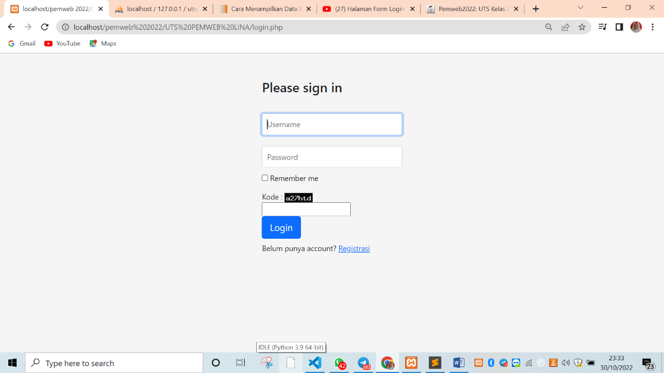
Pada menu tersebut jika belum memiliki akun bisa kill registrasi terlebih dahulu. Dan akan ditujukan ke form registrasi.
- Form Registrasi
Script:
<?php

require 'koneksi.php';

if (isset($_POST["registrasi"])) {
if (registrasi($_POST) > 0) {
echo "
<script>
alert('Registrasi berhasil');
document.location.href = 'index.php';
</script>
";
} else {
echo mysqli_error($koneksi);
}
}
?>

<!DOCTYPE html>
<html>
<head>
<meta charset="UTF-8">
<meta http-equiv="X-UA-Compatible" content="IE=edge">
<meta name="viewport" content="width=device-width, initial-scale=1.0">
<title>Pendaftaran Industri Rumah Tangga di Kementerian PANRB </title>

<style type="text/css">
body{
background-color: darkgray;
}
</style>

</head>
<body >

<form method="POST" name="frmpost" action="" enctype="multipart/form-data">
<table align="center" border="2" cellpadding="2" cellspacing="2">
<tr align="center"><td><h2> <b>Registrasi Industri Rumah Tangga di Kementerian PANRB</b></h2></td></tr>

<tr>
<td>
<table width="450" border="0" cellpadding="0" cellspacing="10" align="center">
<tr>
<td>Username</td>
<td> : </td>
<td><input name="username" type="username" size="40" /></td>
</tr>

<tr>
<td>Password</td>
<td> : </td>
<td><input name="password" type="password" size="40" /></td>
</tr>

<tr>
<td>Ulangi Password</td>
<td> : </td>
<td><input name="ulangPassword" type="password" size="40" /></td>
</tr>

<tr>
<td>Nama Usaha</td>
<td> : </td>
<td><input name="namaUsaha" type="text" size="40" /></td>
</tr>

<tr>
<td>Alamat</td>
<td> : </td>
<td><input name="alamat" type="alamat" size="40" /></td>
</tr>

<tr>
<td>Golongan Usaha</td>
<td> : </td>
<td>
<input type="radio" name="golongan" value="mikro"><label for="mikro">mikro</label>

<input type="radio" name="golongan" value="kecil"><label for="kecil">kecil</label>

<input type="radio" name="golongan" value="menengah"><label for="menengah">menengah</label>

</td>
</tr>

<tr>
<td>Modal</td>
<td> : </td>
<td>
<input type="checkbox" name="modal" value="bank"><label for="bank">Bank</label>

<input type="checkbox" name="modal" value="koperasi"><label for="koperasi">Koperasi</label>

<input type="checkbox" name="modal" value="bantuansosial"><label for="bantuansosial">Bantuan Sosial</label>
</td>
</tr>

<tr>
<td>Nama Pemilik</td>
<td> : </td>
<td><input name="namaPemilik" type="text" size="40" /></td>
</tr>

<tr>
<td>Tempat Lahir</td>
<td> : </td>
<td><input name="tempatLahir" type="text" size="40" /></td>
</tr>

<tr>
<td>Tanggal Lahir</td>
<td> : </td>
<td><input name="tanggalLahir" type="date" size="40" /></td>
</tr>

<tr>
<td>Nomor Telepon</td>
<td> : </td>
<td><input name="nomorTelepon" type="text" size="40" /></td>
</tr>

<tr>
<td>Email</td>
<td> : </td>
<td><input name="email" type="email" size="40" /></td>
</tr>

<tr>
<td>Scan KTP</td>
<td> : </td>
<td>
<input name="scanKTP" type="file" size="40" /><br>
<small>wajib png/jpg/jpeg</small><br>
</td>
</tr>

<tr>
<td>Scan NPWP</td>
<td> : </td>
<td>
<input name="scanNPWP" type="file" size="40" /><br>
<small>wajib png/jpg/jpeg</small><br>
</td>
</tr>

<tr>
<td colspan="4" align="center"><input type="submit" name="registrasi" value="Registrasi"/></td>
</tr>
</table>
</td>
</tr>
</table>
</form>
</body>
</html>
Dan hasil outputnya:
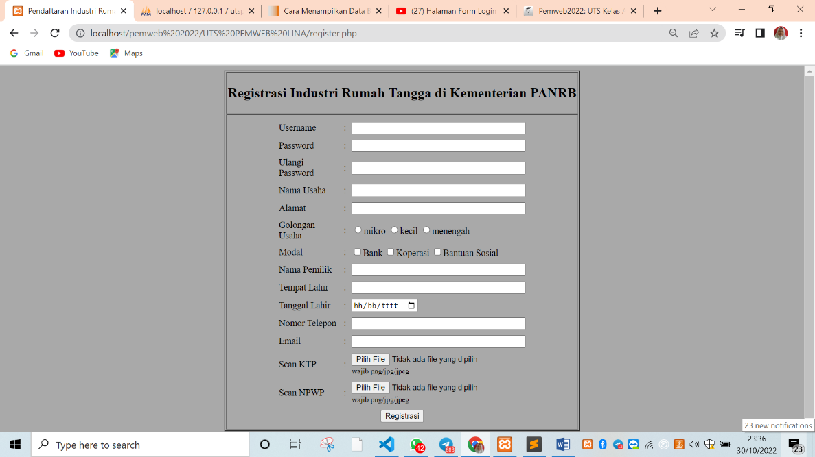

Pada form diatas kita harus mengisi data diri terlebih dahulu agar bisa memiliki username dan password yang mana nanti akan digunakan untuk login. Setelah selesai maka data kita akan masuk ke dalam database. Berikut gambar data yang sudah masuk kedalam database.

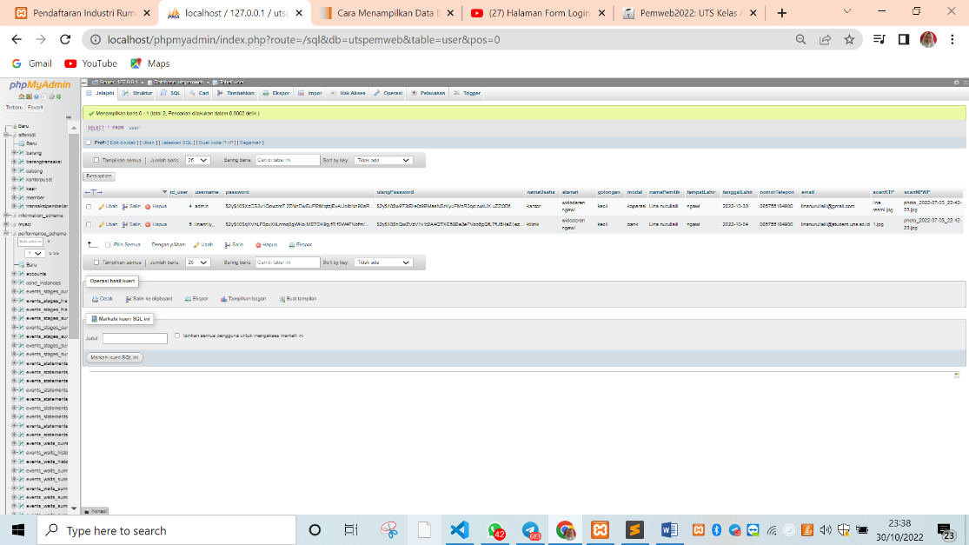

Setelah data terisi dengan benar maka secara otomatis kita akan diarahkan pada form login. Setelah itu kita harus mengisi username dan password beserta captcha nya dan klik login. Lalu kita masuk ke halaman dashboard.
- Halaman Dashboard
Script:
<?php
//inisialisasi session
session_start();

$nama_usaha = $_SESSION["username"];

//mengecek username pada session
if( !isset($_SESSION['username']) ){
header('Location: login.php');
exit;
}

require 'koneksi.php';
?>

<!DOCTYPE html>
<html lang="en">
<head>
<meta charset="utf-8">
<meta name="viewport" content="width=device-width, initial-scale=1, shrink-to-fit=no">
<link href="https://cdn.jsdelivr.net/npm/bootstrap@5.0.2/dist/css/bootstrap.min.css" rel="stylesheet" integrity="sha384-EVSTQN3/azprG1Anm3QDgpJLIm9Nao0Yz1ztcQTwFspd3yD65VohhpuuCOmLASjC" crossorigin="anonymous">

</head>
<body>
<center><h1>Halaman Dashboard</h1>
<form method="POST" name="frmpost" action="" enctype="multipart/form-data">
<table align="center" border="3" cellpadding="3" cellspacing="2">
<tr align="center"><td><h2><b>Halo, <?php echo $nama_usaha; ?></b></h2></h2></td></tr>
<tr>
<td>
<table width="450" border="0" cellpadding="0" cellspacing="10" align="center">
<?php
global $koneksi;
$no=1;
$query = mysqli_query($koneksi, "SELECT * FROM user WHERE username = '$nama_usaha'");

while ($item = mysqli_fetch_array($query)) { ?>
<tr>
<td>Nama Usaha</td>
<td> : </td>
<td><?= $item['namaUsaha']; ?></td>
</tr>

<tr>
<td>Alamat</td>
<td> : </td>
<td><?= $item['alamat']; ?></td>
</tr>

<tr>
<td>Golongan</td>
<td> : </td>
<td><?= $item['golongan']; ?></td>
</tr>

<tr>
<td>Modal Usaha</td>
<td> : </td>
<td><?= $item['modal']; ?></td>
</tr>

<tr>
<td>Nama Pemilik</td>
<td> : </td>
<td><?= $item['namaPemilik']; ?></td>
</tr>

<tr>
<td>Tempat Lahir</td>
<td> : </td>
<td><?= $item['tempatLahir']; ?></td>
</tr>

<tr>
<td>tanggal Lahir</td>
<td> : </td>
<td><?= $item['tanggalLahir']; ?></td>
</tr>

<tr>
<td>Nomor Telepon</td>
<td> : </td>
<td><?= $item['nomorTelepon']; ?></td>
</tr>

<tr>
<td>Email</td>
<td> : </td>
<td><?= $item['email']; ?></td>
</tr>

<tr>
<td>Scan KTP</td>
<td> : </td>
<td align=center><?="<img src='image/".$item['scanKTP']."'style='width:70px; height:90px;'>"?></td>
</tr>

<tr>
<td>Scan NPWP</td>
<td> : </td>
<td align=center><?="<img src='image/".$item['scanNPWP']."'style='width:70px; height:90px;'>"?></td>
</tr>

<?php } ?>
</table>
</td>
</tr>
</table>
</form>
<br>
<a href="logout.php"><button class="btn btn-lg btn-primary btn-block">Logout</button></a>
</center>
<script src="https://cdn.jsdelivr.net/npm/bootstrap@5.0.2/dist/js/bootstrap.bundle.min.js" integrity="sha384-MrcW6ZMFYlzcLA8Nl+NtUVF0sA7MsXsP1UyJoMp4YLEuNSfAP+JcXn/tWtIaxVXM" crossorigin="anonymous"></script>
</body>
</html>
Hasil output:

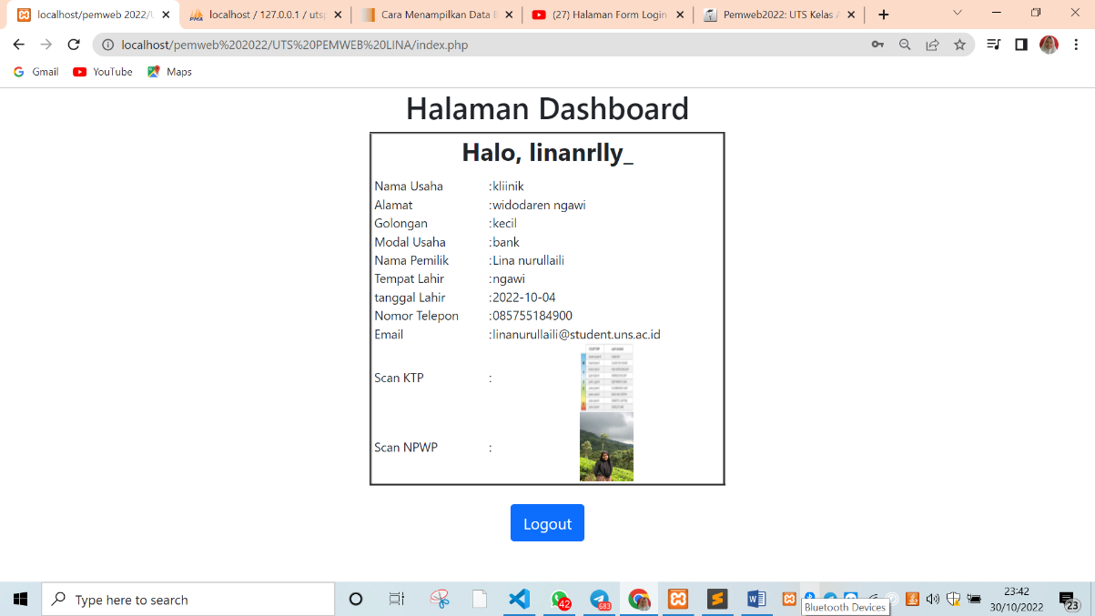

Pada halaman dashboard ini terdapat tampilan data pribadi user sesuai dengan username dan password yang dimasukkan ketika login. Jika user menginginkan logout maka kli tombol logout maka user akan dikembalikan pada halaman login.

